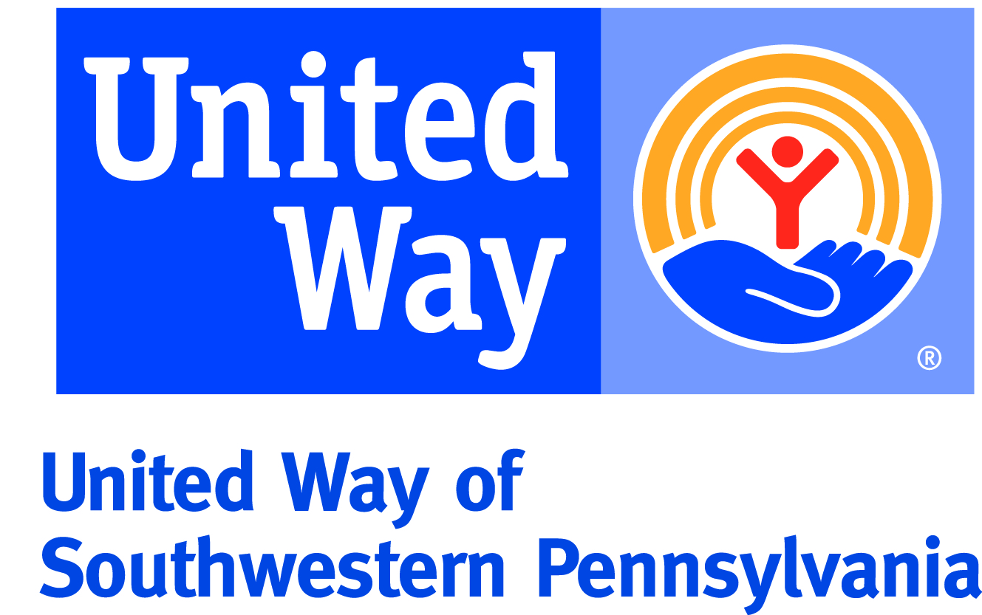
2022-23 Campaign
Social Media Toolkit

Change is here. Join us to make it a change for the better. United Way of Southwestern Pennsylvania has refocused our efforts on what we do best: meet basic needs, move families and individuals toward financial stability, and build for success in school and life. With the support of changemakers like you, we can tackle the big issues today and whatever challenges tomorrow brings.

Whether we are together in person or not, your annual workplace campaign offers an exciting way to unite your teams live or virtually and celebrate the great work you’re doing to help the community. Share how your organization is supporting United Way and, together, we can showcase the great spirit, creativity, and generosity of the people in our region.

Creating dynamic social media coverage of your campaign will…
- Help unite your team, and their families, around a common cause
- Highlight the great work you are doing to help community members in need
- Give you, the community and United Way the opportunity to thank and celebrate employee volunteers and donors

Follow these simple steps to promote your organization’s United Way campaign:

Before campaign
Make sure we’re connected online! Follow United Way on the social media channels your organization uses and encourage employees to do the same.
- Facebook - facebook.com/unitedwayswpa
- Twitter - twitter.com/unitedwayswpa (@unitedwayswpa)
- Instagram - instagram.com/unitedwayswpa (@unitedwayswpa)
- LinkedIn - linkedin.com/company/united-way-of-southwestern-pennsylvania

Campaign launch
Announce the launch of your Workplace campaign on the social media channels your organization uses and encourage employees to do the same.
- Share why your organization is hosting a United Way campaign, highlight the increased need in our community, and include what you hope to accomplish
  - Example: We’re excited to launch our 5th annual Workplace campaign for United Way of Southwestern Pennsylvania! This year’s campaign will be like no other and we’re looking forward to some fun while we raise funds to help our neighbors meet basic needs, move toward financial stability and build success in school and life. #ChangemakersUnite
- Encourage employees to share the announcement of the campaign and why they are excited about it
  - Example: I’m happy to be on team that’s staying connected and helping others. I want to learn more about United Way and do my part to help. Watch out for more updates from our campaign! #ChangemakersUnite
- Make sure to tag United Way and use the campaign hashtag: #ChangemakersUnite

Mid-campaign update
Keep your family, friends and peers updated on campaign events and progress via social media. Each month, United Way will be sharing campaign highlights so we can’t wait to see your virtual activities!
- Share photos and information on your campaign
  - Tip: Issuing a post, going live on Facebook or authoring a blog post are great ways to spread the word.
  - Example: We wanted to take a moment and update you on our United Way Workplace campaign. So far, we’ve hosted Zoom trivia nights, participated in themed-days and even had a virtual dance-off to raise funds for United Way of Southwestern Pennsylvania. There’s more to come so stay tuned. #ChangemakersUnite
- Highlight employees who are going above and beyond to make a difference.
  - Tip: Consider choosing an employee to ‘take over’ your social media accounts for a day to show how they are getting involved.
- Encourage employees to share their activities on social media.
  - If the employees are completing projects at home, ask them to take and share photos with a message about how they’re contributing to the campaign.
    - Example: Tonight, we are making literacy kits! As part of our United Way workplace campaign, I pledged to build 10 kits for local kids. #ChangemakerseUnite
- Make sure to tag United Way and use the campaign hashtag: #ChangemakersUnite

Campaign recap
After a great campaign, make sure to share an update on social media about how it went!
- Publish a recap photo album including some of your employee’s favorite moments or achievements during the campaign
- Thank your team for their good work to help the community
- Make sure to tag United Way and use the campaign hashtag: #ChangemakersUnite

